

(Accredited by NAAC & NBA, Approved By A.I.C.T.E., New Delhi, Permanently Affiliated to JNTU, Hyderabad)
(Aziz Nagar, C.B.Post, Hyderabad -500075)

Department of Computer Science and Engineering
(Artificial Intelligence and Machine Learning)

OBJECT ORIENTED PROGRAMMING THROUGH JAVA LAB
LAB PROJECT REPORT
TITLE: Todo List
By
25911A66XX | BHIMAPANGU SOWMYA
25911A66XX | KARLA HASINI REDDY
25911A66XX | VANKUDOTH BINDHU

Submitted to
Ms. G SUREKHA
Assistant Professor

TODO LIST
1.OBJECTIVE
The primary objective of this project is to design and implement a simple, user-friendly Todo List web application using the Django framework. The application enables users to efficiently manage their daily tasks through a clean interface and robust backend logic. This project emphasizes the implementation of full CRUD (Create, Read, Update, Delete) functionality
2.TOOLS & TECHNOLOGIES
- Language: Core Java
- Framework: Servlets (Java EE)
- Database: SQLite / MySQL (via JDBC)
- Frontend: JSP, HTML, CSS
- IDE: Eclipse / IntelliJ IDEA / NetBeans
- Server: Apache Tomcat
- Browser: Chrome / Firefox
3. INTRODUCTION
This project focuses on building a simple, user-friendly Todo List web application using Servlets and JDBC, with complete CRUD functionality to:
- Add, view, update, and delete tasks
- Track task completion status
- Handle form input and validation
It reinforces core web development concepts such as:
- MVC architecture (Model, DAO, Servlet, JSP)
- Servlet lifecycle (doGet, doPost)
- JDBC database connectivity
- JSP for dynamic rendering
4. CODE WITH PROJECT STRUCTURE
todo_project/
├── src/
│ ├── com.todoapp/
│ │ ├── model/Todo.java
│ │ ├── dao/TodoDao.java
│ │ ├── servlet/
│ │ │ ├── TodoListServlet.java
│ │ │ ├── TodoCreateServlet.java
│ │ │ ├── TodoUpdateServlet.java
│ │ │ └── TodoDeleteServlet.java
│ │ └── util/DBConnection.java
└── WEB-INF/web.xml
5.code review
5.1Database Schema
CREATE TABLE todos (
id INTEGER PRIMARY KEY AUTOINCREMENT,
title VARCHAR(200),
description TEXT,
completed BOOLEAN DEFAULT 0,
created_at TIMESTAMP DEFAULT CURRENT_TIMESTAMP
);
5.2 Database Operations
Defines the task entity with fields: id, title, description, completed, createdAt.
Handles database operations:
- getAllTodos() → Fetch all tasks
- insertTodo() → Add new task
- updateTodo() → Update existing task
- deleteTodo() → Remove task
- getTodoById() → Fetch single task

5.3 Servlets
- TodoListServlet → Displays all tasks
- TodoCreateServlet → Handles new task creation
- TodoUpdateServlet → Updates existing task
- TodoDeleteServlet → Deletes task
@WebServlet("/todos")
public class TodoListServlet extends HttpServlet {
protected void doGet(HttpServletRequest req, HttpServletResponse resp) throws IOException {
resp.setContentType("text/html");
PrintWriter out = resp.getWriter();
try {
TodoDao dao = new TodoDao();
List<Todo> todos = dao.getAllTodos();

out.println("<h2>Todo List</h2>");
out.println("<a href='/create'>Add Task</a><ul>");
for(Todo t : todos){
out.println("<li><strong>" + t.getTitle() + "</strong> - " + t.getDescription());
out.println(t.isCompleted() ? " ✅ " : " ❌ ");
out.println("<a href='/update?id=" + t.getId() + "'>Edit</a> ");
out.println("<a href='/delete?id=" + t.getId() + "'>Delete</a></li>");
}
out.println("</ul>");
} catch(Exception e){ e.printStackTrace(out); }
}
}
@WebServlet("/create")
public class TodoCreateServlet extends HttpServlet {
protected void doGet(HttpServletRequest req, HttpServletResponse resp) throws IOException {
PrintWriter out = resp.getWriter();
out.println("<h2>Add Task</h2>");
out.println("<form method='post'>");
out.println("Title: <input type='text' name='title'><br>");
out.println("Description: <textarea name='description'></textarea><br>");
out.println("Completed: <input type='checkbox' name='completed'><br>");
out.println("<button type='submit'>Save</button>");
out.println("</form>");
} protected void doPost(HttpServletRequest req, HttpServletResponse resp) throws IOException {
try {
Todo todo = new Todo();
todo.setTitle(req.getParameter("title"));
todo.setDescription(req.getParameter("description"));
todo.setCompleted(req.getParameter("completed") != null);
new TodoDao().insertTodo(todo);
resp.sendRedirect("todos");
} catch(Exception e){ e.printStackTrace(); }
}
}

6. Execution Steps
- Configure Tomcat in your IDE.
- Create database (todo.db for SQLite or MySQL schema).
- Update DBConnection.java with correct JDBC URL.
- Deploy project to Tomcat.
- Run: http://localhost:8080/todo_project/todos.

7. Output Screens
- Todo List Page → Displays all tasks with status ✅/❌
- Add Task Page → Form generated by servlet
- Edit Task Page → Update form generated by servlet
- Delete Confirmation Page → Confirmation generated by servlet
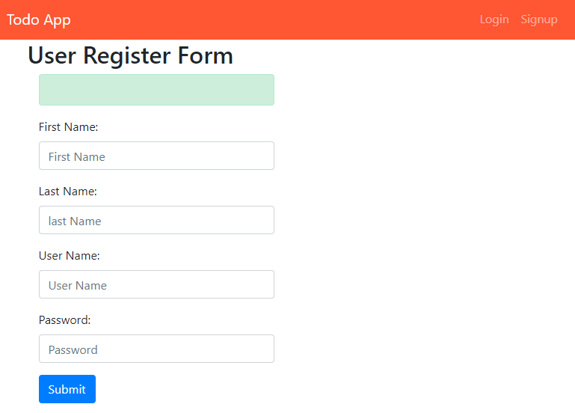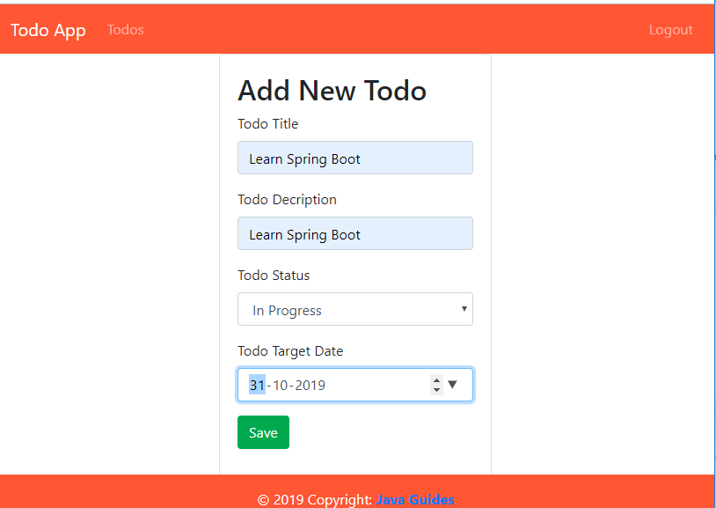

8. Applications
- Education → Student task tracking
- Software Teams → Sprint planning
- Marketing → Campaign task management
- Healthcare → Patient follow-up tasks
- Freelancing → Project deadlines
- Event Planning → Schedule management

9. Conclusion
This implementation demonstrates how to build a CRUD Todo List app without JSP, using only Servlets + JDBC. The servlets themselves generate HTML responses, making the project lightweight and easy to understand.

Future Scope
- Add CSS/JavaScript for better UI.
- Implement user authentication.
- Extend with REST APIs for integration with front-end frameworks.

